Craig Hulsebus

CSC 137-03

Project 2: Design an 8-bit adder/subtractor

Spring 2018

Block Diagram

Design & Outputs

8-bit adder/subtractor

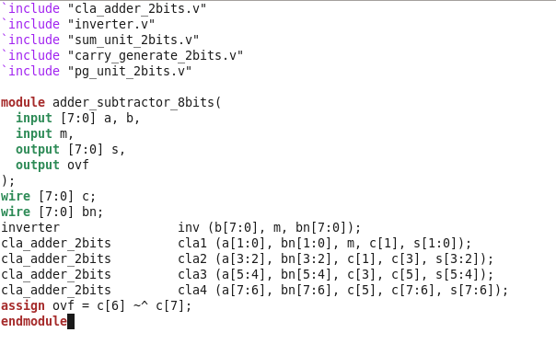

8-bit Invertor

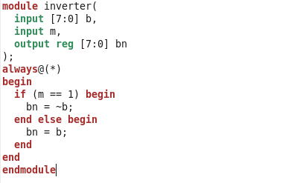

2-bit CLA adder

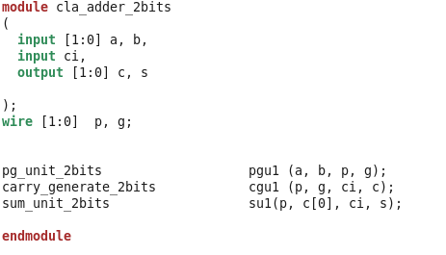

PGU

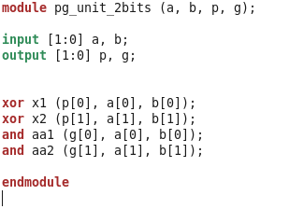

CGU

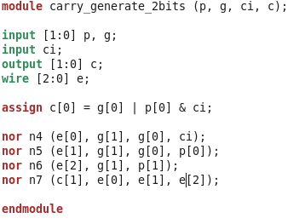

SU

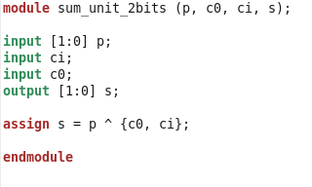

Analysis of Results

Test Bench

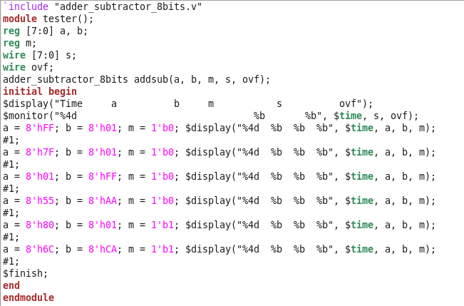

Test Cases Done by Hand

Test Cases Done by Hand (cont)

SIMV

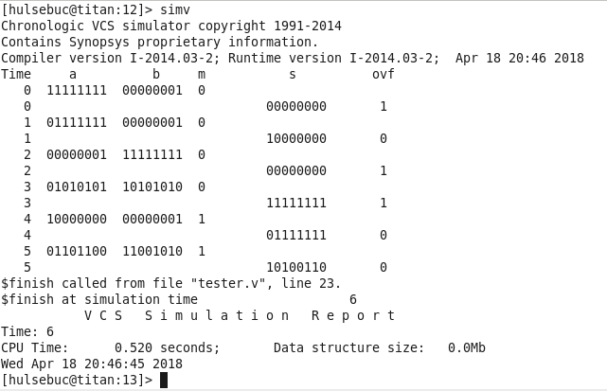

Analysis